Sporadic Polyp and Post Colorectal Cancer Resection Surveillance in Average Risk Patients: Nurse Endoscopist Led Virtual Clinic Guidelines and Operational Policy

Introduction
This policy details the nurse endoscopist led virtual clinic for colonic surveillance in average risk patients post colorectal cancer and polypectomy (sporadic polyps), to ensure appropriate implementation of The British Society of Gastroenterology (BSG), Public Heath England (PHE) and and Association of Coloproctology Great Britain & Ireland guidelines (ACPGBI)¹ . The virtual clinic will assist with planning the frequency and duration of surveillance colonoscopy in average risk patients post polypectomy and post cancer resection.
Colonoscopy is not without risk and endoscopists must assess patients accordingly to see if they are medically fit to undergo colonoscopy surveillance and if they consent to be placed on a surveillance programme. This protocol is only relevant for average risk patients diagnosed with sporadic premalignant polyps and/or post colorectal cancer resection.
Background
Colorectal cancer (CRC) is a major cause of mortality in the United Kingdom: over 40,000 people are diagnosed and over 16,000 people die from the disease each year¹. The vast majority of CRCs arise from premalignant polyps, a process that takes many years². Endoscopic polypectomy is effective in reducing CRC incidence and mortality³.
Some patients who have premalignant polyps (adenomas or serrated polyps) detected at colonoscopy are more likely to develop metachronous polyps or colorectal cancer⁴⁻⁶. Endoscopic follow-up of patients with such polyps is referred to as a post-polypectomy surveillance colonoscopy. Surveillance aims to detect and resect metachronous premalignant polyps and to detect lesions missed on the initial examination, thereby preventing cancer and reducing CRC mortality; however, no randomised trial has directly assessed the benefit of post-polypectomy or post-cancer-resection surveillance.
Premalignant polyps are common, occurring in about a quarter to a half of all people of screening age⁷⁻¹⁰, yet only about 5% of the population will develop CRC during their life; thus, only a minority of people with polyps will develop CRC, and thus the majority of people would not and hence cannot benefit from post-polypectomy surveillance. Indeed, it is an increasingly held view that the greatest benefit in terms of CRC prevention is derived from the initial polypectomy, rather than from subsequent surveillance. Studies have shown that it is possible to stratify the CRC risk and to identify cohorts of patients with a persisting CRC risk beyond index polypectomy¹¹⁻¹², yet even with current risk stratification, surveillance places a considerable burden on endoscopy services: between 10 and 20% of colonoscopies are performed for surveillance¹³.

Exclusion criteria
This policy is relevant to average risk patients found to have sporadic premalignant polyps at colonoscopy or those post colorectal cancer resection only, the following patient groups will not be included as they currently are part of specific surveillance programmes managed seperately.
- Family history of cancer patient – under the care of Family Cancer Clinic.
- Lynch syndrome patients – under care of Family Cancer Clinic
- FAP and any polyposis syndromes – under care of Polyposis Registry

Operational Policy for Virtual Surveillance Clinic:
- The endoscopist who performs the colonoscopy and polypectomy is responsible for reviewing the polyp histology within 2 weeks, and acting on any non-benign findings.
- Patients diagnosed with polyps at colonoscopy/flexible sigmoidscopy cannot be placed on an automatic recall for colonoscopy unless this is needed within 12 months for non-surveillance reasons i.e. polypectomy site check, polyp recurrence or residual polyps in situ.
- In the recall box on the Endovault report the option ‘recall to be decided after review in sproradic polyp and post colorectal cancer virtual clinic ‘ must be completed.
- Colonoscopic surveillance should be determined utilising the BSG/PHE/ACPGBI guidance (see table 1 below).
- The nurse endoscopist led virtual surveillance clinic will assess the histology of patients found to have premalignant at colonoscopy, utilising the guidelines to recommend patients to either have further surveillance or be discharged back to the GP.
- Average risk patients post colorectal cancer resection who have no other pre-malignant polyps will be recalled at 1 and 3 years post cancer resection. If polyps are detected, then they will follow the guidelines as for patients with sporadic polyps.
- The clinic will distribute a letter to both GP and patients advising them of the appropriate surveillance strategy, intervals or discharge. Letters will be uploaded to EPRO and a clinical note placed on GCIS.
- A CT virtual colonoscopy (CTVC) may be more appropriate for subsequent surveillance, especially if the patient had a technically difficult procedure, or has other relevant co-morbidities. This will be decided by the virtual clinic, and the GP advised to request this at the appropriate interval.
- In difficult cases, it may be decided that an outpatient review is needed before deciding on any surveillance. In this situation the outcome of the virtual clinic review will be communicated to the patient, GP and/or relevant consultant, to ensure an appointment is made.
- The outcome of the virtual clinic will be communucated to the endoscopy admin team, including the relevant surveillance recall code. The admin team will place the patient on the relevant trust database recall.

Definitions

The following definitions are used in these guidelines:
Serrated polyp: the umbrella term used to describe hyperplastic polyps, sessile serrated lesions (SSL), SSLs with dysplasia (SSLd), traditional serrated adenomas (TSA) and mixed polyps.
Premalignant polyp: the term includes both serrated polyps (excluding diminutive [1-5mm] rectal hyperplastic polyps) and adenomatous polyps. It does not include other, benign polyps such as post-inflammatory polyps.
Advanced serrated polyp: a serrated polyp of at least 10mm in size or containing any grade of dysplasia.
Advanced adenomatous polyp: an adenoma of at least 10mm in size or containing high-grade dysplasia. Note – international definitions also include tubulovillous or villous histology, but these are not part of the UK definition.
Advanced colorectal polyp: the term includes both advanced serrated polyps and advanced adenomatous polyps.
Advanced neoplasia: this term has been used historically to describe the combination of advanced adenomas and colorectal cancers. The GDG feels that the term is outmoded, firstly because it does not include lesions from the serrated pathway, and secondly because it combines 2 entities that have very different clinical significance.

Table 1: Post-polypectomy surveillance recommendations by age
Colonoscopy findings | High-risk criteria | Low-risk (premalignant polyp[s] but no high-risk criteria) | No polyps
Within national bowel screening age range or within 10 years of lower age limit | Colonoscopy after 3 years | Participate in national bowel screening when invited | Participate in national bowel screening when invited
More than 10 years younger than national bowel screening lower age limit | Colonoscopy after 3 years | Consider colonoscopy after 5 or 10 years, individualised to their age and other risk factors | Participate in national bowel screening when invited
At least 75 years old, or if life expectancy <10 years | In general, no colonoscopic surveillance recommended
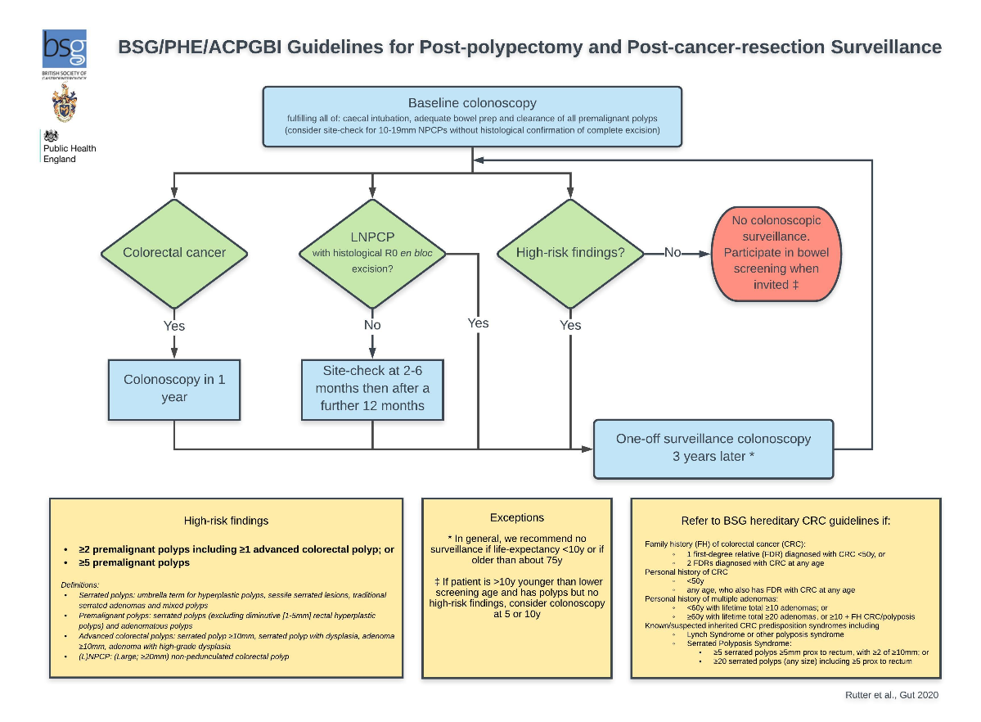

Appendix 1

Dear Patient
This letter comes to you from the endoscopy department. We have recently reviewed your medical records regarding your previous colonoscopy and polyp findings. Based on new national guidelines, undergoing a further colonoscopy is more likely to cause harm than result in any benefit for you. We therefore would not recommend further routine colonoscopy procedures.
If you are between the ages of 60-74 you will still be invited to take part in the NHS Bowel Cancer Screening Programme, which involves returning a stool test kit every 2 years, and we recommend that you continue to participate in the screening programme.
It is important to be aware of any unusual bowel symptoms lasting for more than 3 weeks, such as:
- change in bowel habit
- bleeding from the back passage
- abdominal pain
- a lump in your abdomen
- unexplained weight loss
If you experience any of these symptoms, please arrange an appointment with your GP.
If you have any questions or concerns please either see your GP or contact the polyp clinic on XXX or by email to XXX
Yours sincerely,

Dr X
Consultant gastroenterologist
Clinical lead for endoscopy
X NHS Trust
Appendix 2
Surveillance Recall Codes:
- BP18: Sporadic polyp 12 month or less recall (e.g. site check post EMR; incomplete polypectomy)
- BP19: Sporadic polyp >12 month recall
- BC19: Post colorectal cancer 1 year recall
- BC20: Post colorectal cancer >1 year recall
- BS18: Family History 2 year or less recall
- BS19: Family History >2yr recall
- BF19: Polyposis
- BU18: IBD high risk 12 month or less recall
- BU19: IBD non-high risk >12 month recall
References:

1.Cancer Research UK; 2019 [Available from: https://www.cancerresearchuk.org/aboutcancer/bowel-cancer/about-bowel-cancer.
2. Fearon ER, Vogelstein B. A genetic model for colorectal tumorigenesis. Cell. 1990;61(5):759-
67.
3. Zauber AG, Winawer SJ, O'Brien MJ, Lansdorp-Vogelaar I, van Ballegooijen M, Hankey BF, et
al. Colonoscopic polypectomy and long-term prevention of colorectal-cancer deaths. N Engl J Med.
2012;366(8):687-96.
4. Robertson DJ, Greenberg ER, Beach M, Sandler RS, Ahnen D, Haile RW, et al. Colorectal Cancer
in Patients Under Close Colonoscopic Surveillance. Gastroenterology. 2005;129(1):34-41.
5. Cottet V, Jooste V, Fournel I, Bouvier AM, Faivre J, Bonithon-Kopp C. Long-term risk of
colorectal cancer after adenoma removal: a population-based cohort study. Gut. 2011.
6. East JE, Atkin WS, Bateman AC, Clark SK, Dolwani S, Ket SN, et al. British Society of
Gastroenterology position statement on serrated polyps in the colon and rectum. Gut. 2017.
7. Lieberman DA, Weiss DG, Bond JH, Ahnen DJ, Garewal H, Chejfec G. Use of colonoscopy to
screen asymptomatic adults for colorectal cancer. Veterans Affairs Cooperative Study Group 380.
NEnglJMed. 2000;343(3):162-8.
8. Imperiale TF, Wagner DR, Lin CY, Larkin GN, Rogge JD, Ransohoff DF. Risk of advanced proximal
neoplasms in asymptomatic adults according to the distal colorectal findings. The New England journal
of medicine. 2000;343(3):169-74.
9. Regula J, Rupinski M, Kraszewska E, Polkowski M, Pachlewski J, Orlowska J, et al. Colonoscopy
in colorectal-cancer screening for detection of advanced neoplasia. The New England journal of
medicine. 2006;355(18):1863-72.
10. Hassan C, Pickhardt PJ, Kim DH, Di Giulio E, Zullo A, Laghi A, et al. Systematic review:
distribution of advanced neoplasia according to polyp size at screening colonoscopy. Aliment
Pharmacol Ther. 2010;31(2):210-7.
11. Atkin WS, Morson BC, Cuzick J. Long-term risk of colorectal cancer after excision of
rectosigmoid adenomas. NEnglJMed. 1992;326(10):658-62.
12. Martinez ME, Baron JA, Lieberman DA, Schatzkin A, Lanza E, Winawer SJ, et al. A pooled analysis of advanced colorectal neoplasia diagnoses after colonoscopic polypectomy. Gastroenterology. 2009;136(3):832-41.
13. SCOPING THE FUTURE: An evaluation of endoscopy capacity across the NHS in England. Cancer research UK publication. 2015.

